Estimation And Confidence Intervals
a. Build 99% Confidence Interval Using Sample Standard Deviation
Assuming the sample is representative of the population, construct a 99% confidence interval for the mean number of characters printed before the print-head fails using the sample standard deviation. Explain the steps you take and the rationale behind using the t-distribution for this task.
Steps for Building the Confidence Interval
1. Check Assumptions
- Sample Size: The sample size is n=15n = 15n=15, which is relatively small (n<30n < 30n<30).
- Population Distribution: Since the sample size is small, we assume that the population follows a normal distribution or is approximately normal.
- Standard Deviation: We use the sample standard deviation sss, as the population standard deviation σ\sigmaσ is unknown.
Given these conditions, we use the t-distribution for constructing the confidence interval.
2. Calculate Sample Statistics
The sample mean xˉ\bar{x}xˉ and the sample standard deviation sss are calculated using the data:
Data: 1.13,1.55,1.43,0.92,1.25,1.36,1.32,0.85,1.07,1.48,1.20,1.33,1.18,1.22,1.29
- xˉ=average of the data\bar{x} = \text{average of the data}xˉ=average of the data
- s=standard deviation of the datas = \text{standard deviation of the data}s=standard deviation of the data
3. Determine the t-Critical Value
For a 99% confidence interval and n−1=14n-1 = 14n−1=14 degrees of freedom, we find the critical value t∗t^*t∗ from the t-distribution table or software.
4. Compute the Margin of Error
The margin of error (ME) is calculated as:
ME=t∗⋅sn\text{ME} = t^* \cdot \frac{s}{\sqrt{n}}ME=t∗⋅n​s​
5. Construct the Confidence Interval
The confidence interval is given by:
CI=(xˉ−ME,xˉ+ME)\text{CI} = \left( \bar{x} - \text{ME}, \bar{x} + \text{ME} \right)CI=(xˉ−ME,xˉ+ME)
6. Interpret the Results
The interval provides a range in which the true population mean durability is likely to lie, with 99% confidence.

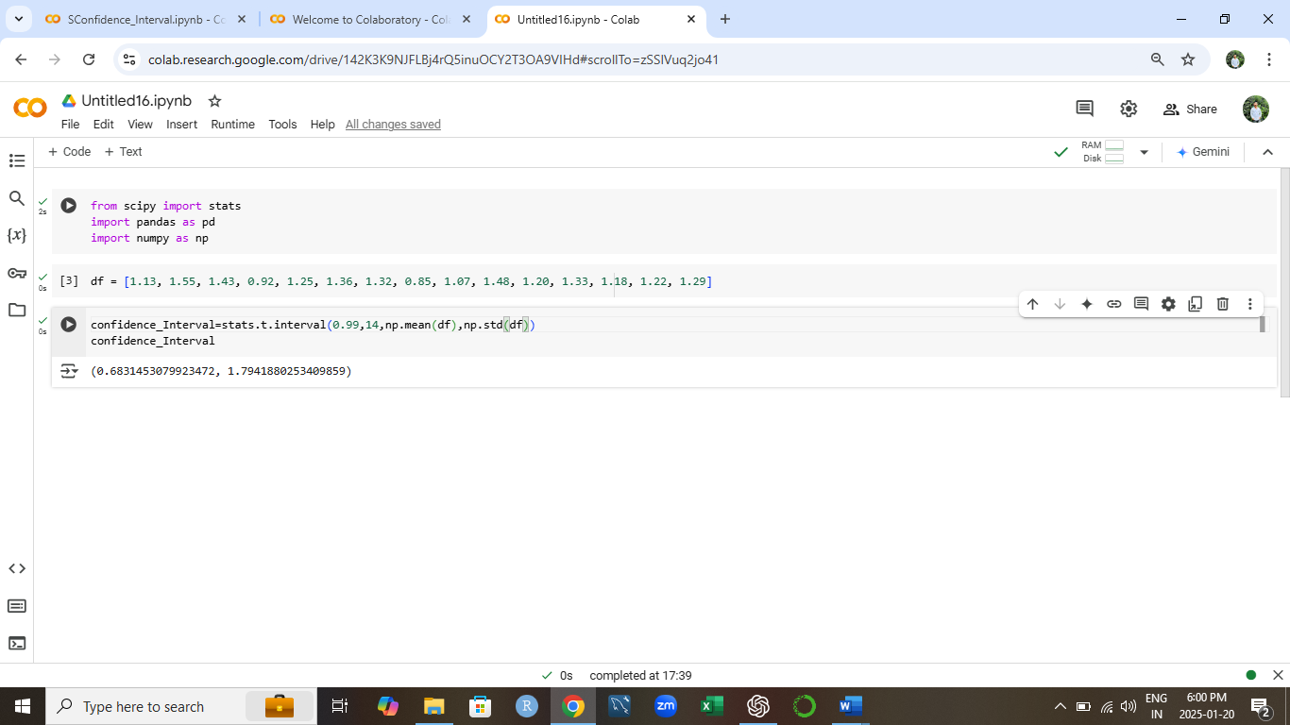

b. Build 99% Confidence Interval Using Known Population Standard Deviation
If it were known that the population standard deviation is 0.2 million characters, construct a 99% confidence interval for the mean number of characters printed before failure.

Step 1: Gather the given information
- Sample size (nnn) = 15
- Population standard deviation (σ\sigmaσ) = 0.2
- Sample mean (xˉ\bar{x}xˉ) = Sum of all sample valuesn\frac{\text{Sum of all sample values}}{n}nSum of all sample values​
sample values:
1.13+1.55+1.43+0.92+1.25+1.36+1.32+0.85+1.07+1.48+1.20+1.33+1.18+1.22+1.29
So, xˉ=17.5815=1.172\bar{x} = \frac{17.58}{15} = 1.172xˉ=1517.58​=1.172
- Confidence level = 99%
Corresponding zzz-value for a 99% confidence interval = 2.576 (from standard normal distribution tables).

Step 2: Use the formula for the confidence interval
The confidence interval for the population mean when the population standard deviation is known is:
xˉ±z⋅σn\bar{x} \pm z \cdot \frac{\sigma}{\sqrt{n}}xˉ±z⋅n​σ​
Where:
- xˉ\bar{x}xˉ is the sample mean,
- zzz is the z-score for the desired confidence level,
- σ\sigmaσ is the population standard deviation,
- nnn is the sample size.

